11VAL | KT6 6DL
1 BED FLAT
Just Refurbished | Perfect Location | Tranquil Communal Garden | Secure Parking
Description:
On the first floor of this small block. It’s a stone’s throw from the station, but don’t let that deceive you! It’s a tranquil peaceful flat overlooking the large communal gardens. 25 foot open plan kitchen/lounge area opens up with a Juliette balcony. Sparkling new oak floors are a welcome addition to the whole flat. A superb refurbished bathroom with concrete effect tiles and underfloor heating brings a modern touch. Full length Orla Kiely curtains adorn the lounge and bedroom windows. The light filled bedroom has a floor to ceiling height window with garden views, built-in wardrobe, king size bed and new furniture. This flat offers a secure parking bay in the underground carpark and it’s very own bike shed.
Testimonial:
I'd like to thank you for everything you have done whilst I was your tenant, whenever there was a problem it was fixed asap and for that I'm extremely grateful.
T
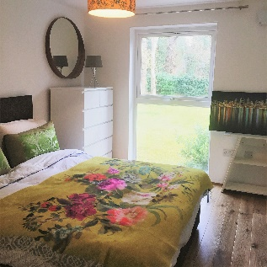

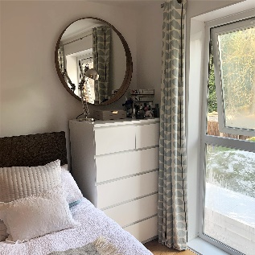

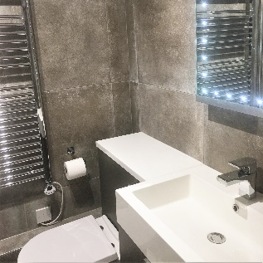

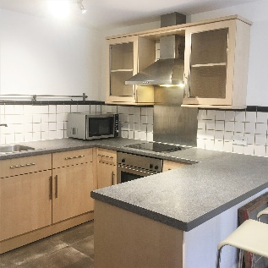

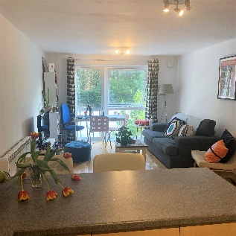

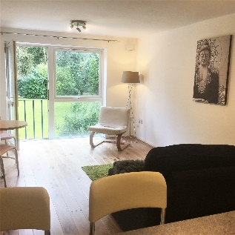

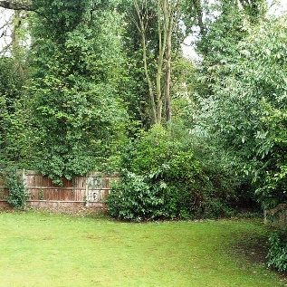

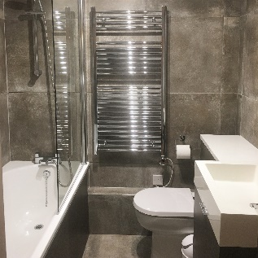

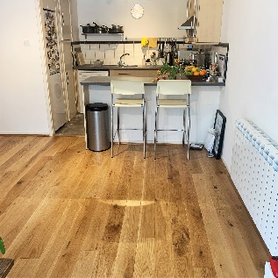

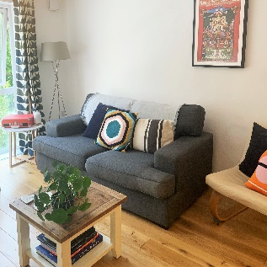

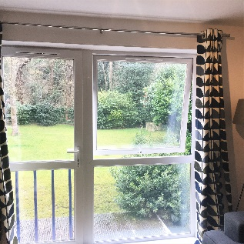

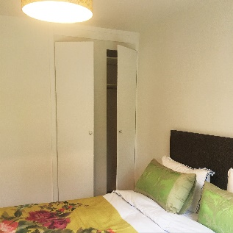

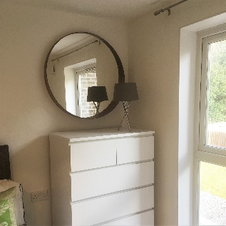

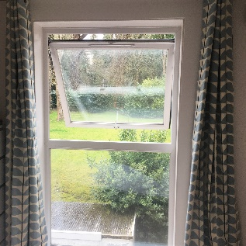

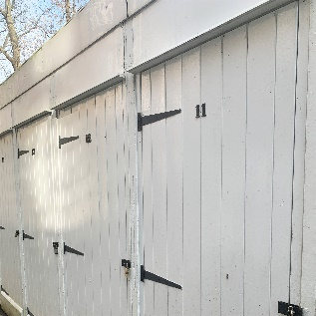

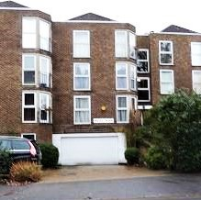

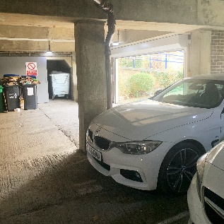

FLOORPLAN: 45 M2

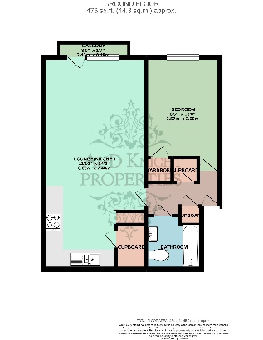
EPC RATING: D

